Celebal Summer Internship 2026
Week 2 Task: E-Commerce Sales Database

Section A — SQL Basics (SELECT, Constraints, Primary Keys)
Q1. Write a query to display all columns and rows from the customer's table.
- By using select * we are displaying the data from customer’s table.
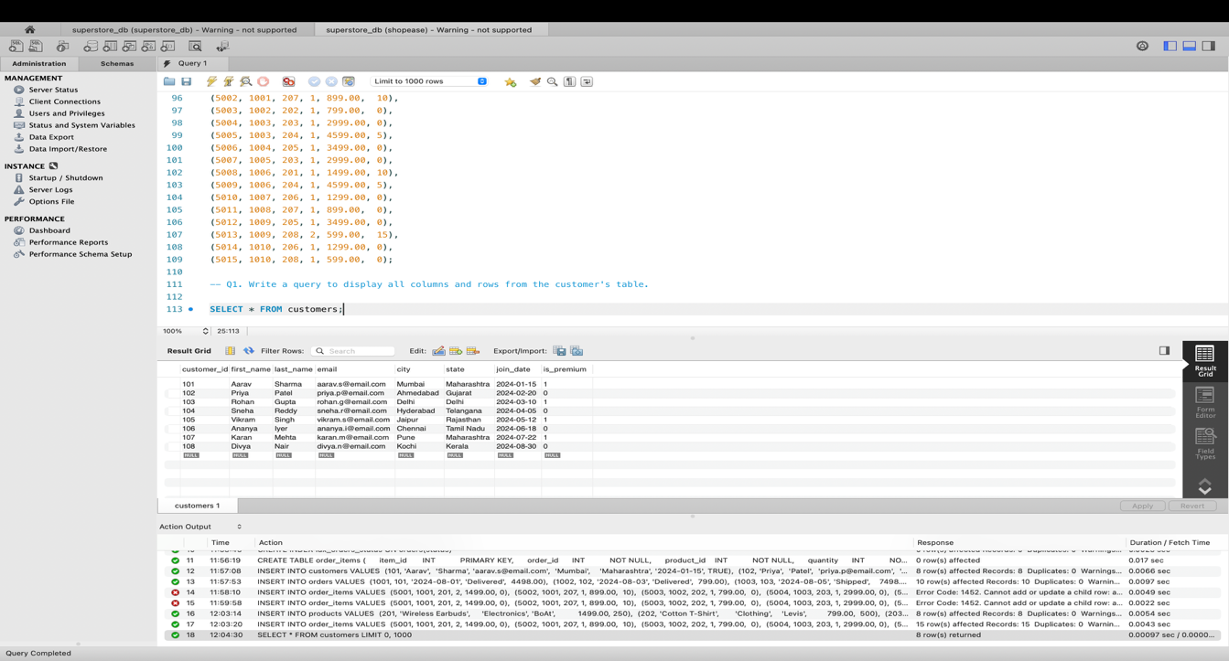

Q2. Retrieve only the first_name, last_name, and city of all customers.
- By naming the columns specifically after select we can get data of first name, last name and city from the customers table.
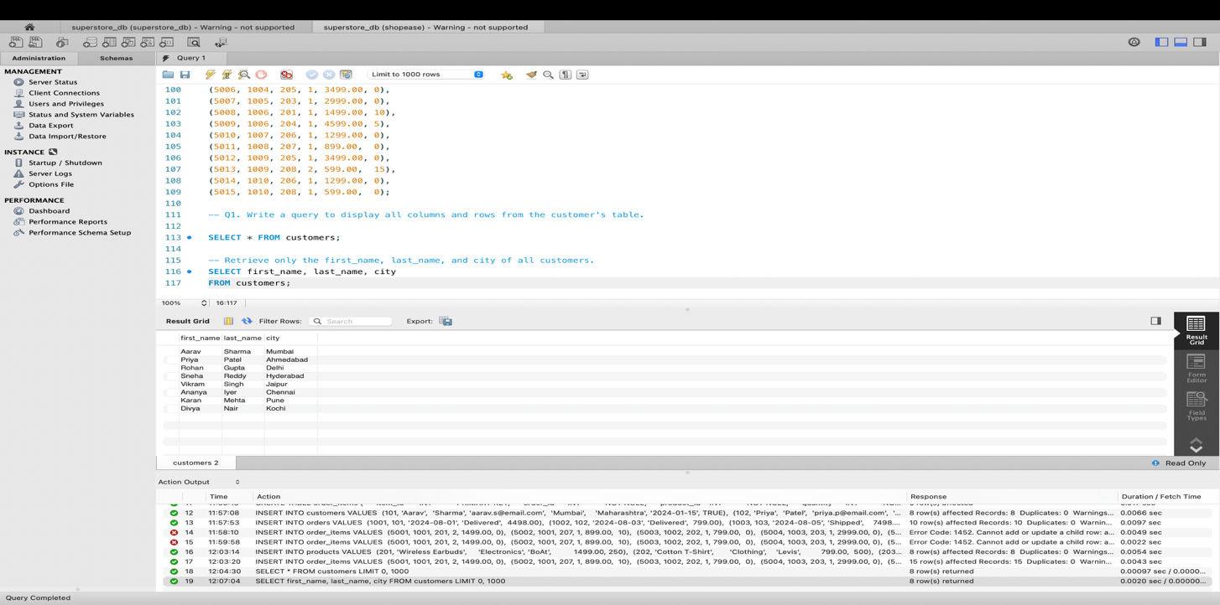
Q3. List all unique categories available in the products table.
- By using distinct keyword we can get the unique values from the table. So I used it for category in the customer table.
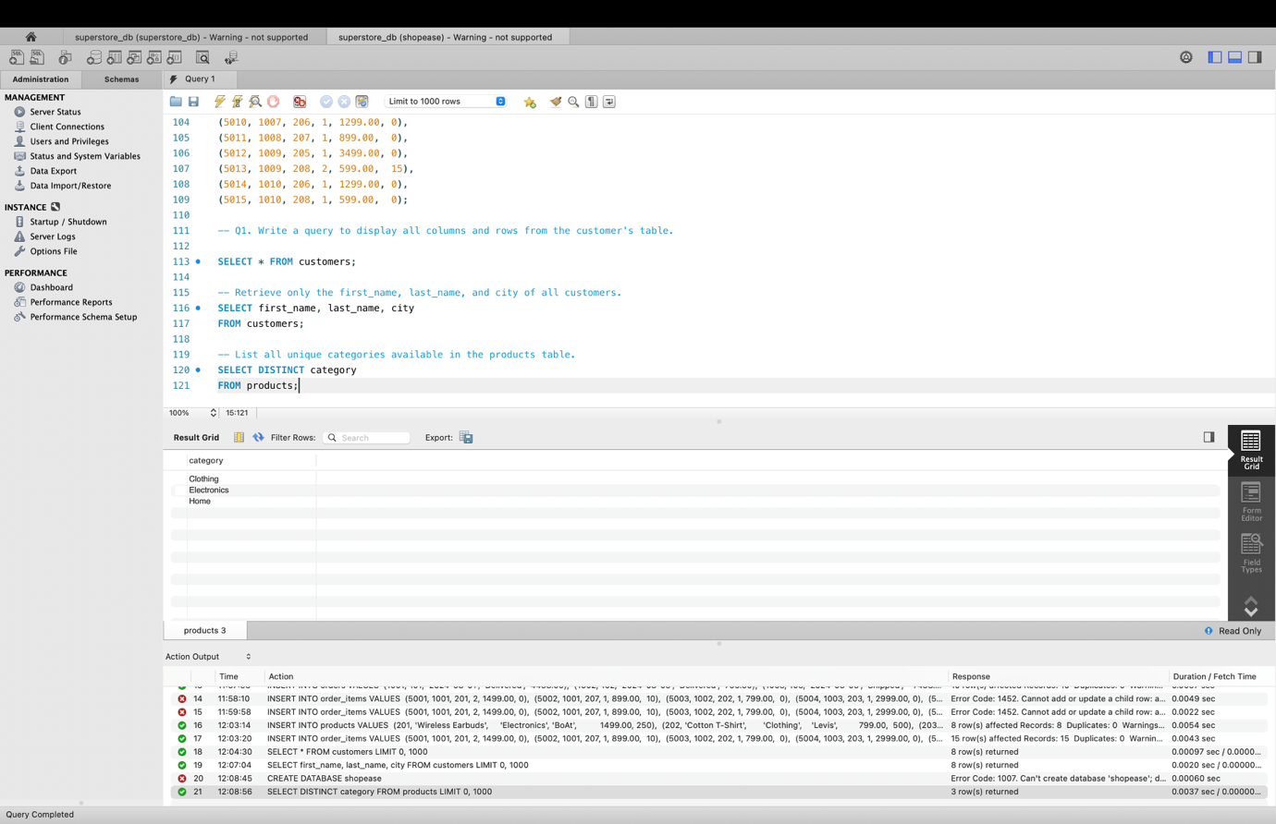
Q4. Identify the Primary Key of each table in the schema. Explain why a Primary Key must be unique and NOT NULL.

- The primary key of each table is as follows
- Customers table – customer_id
- Products table – product_id
- Orders table – order_id
- Order_items table – item_id
- Primary key is important because it identifies every row uniquely and avoids duplicates and it should be not null because every row gets a value so that they are left empty. This helps in identifying distinct values.

Q5. What constraints are applied to the email column in the customers table? What would happen if you tried to insert a duplicate email?

- The contraints applied to email are not null and unique.
- Not null ensures every row has a value in email.
- Unique ensures no two users can have same email address.
- An error will be obtained if we try to insert a duplicate email.

Q6. Try inserting a product with unit_price = -50. What happens and which constraint prevents it? Write both the INSERT statement and explain the error.

- It gives an error when we try to insert unit price with -50.
- The check constrait prevents it as it checks the condition we initialised during the table creation.
- As the unit price is less than 0 it wont insert the values into the table.

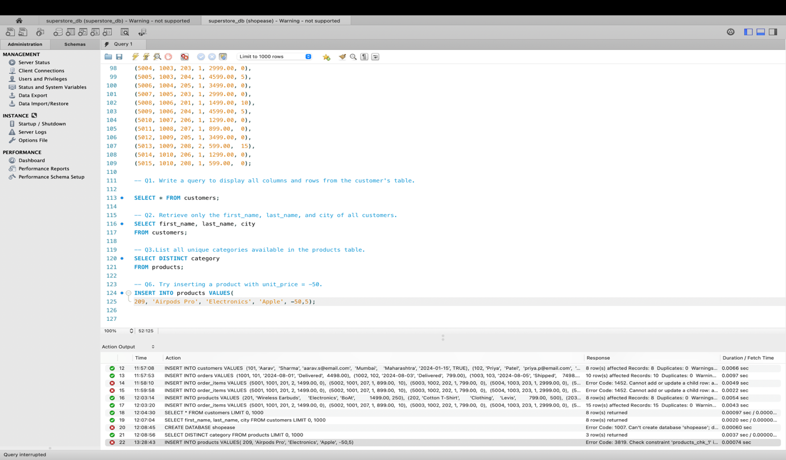

Section B — Filtering & Optimization (WHERE, Indexes)

Q7. Retrieve all orders with status = 'Delivered'.

- To retrieve all orders with status as delivered we have used where and derived data from the products table.

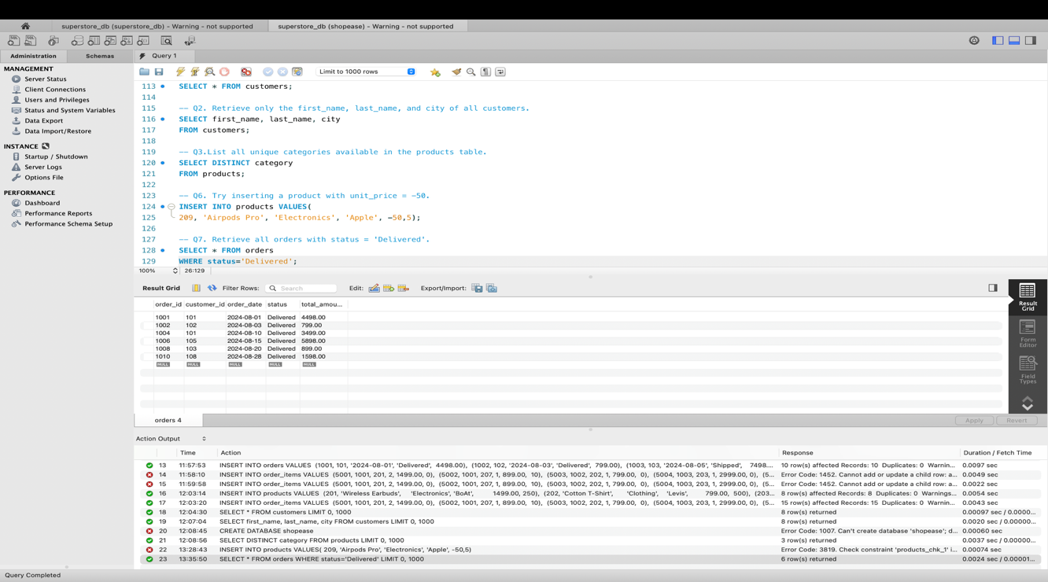
Q8. Find all products in the 'Electronics' category with a unit_price greater than ₹2000.

- Here I have used two conditions joining with and to see the products with electronics category and the unit price greater than 2000 from the products table.

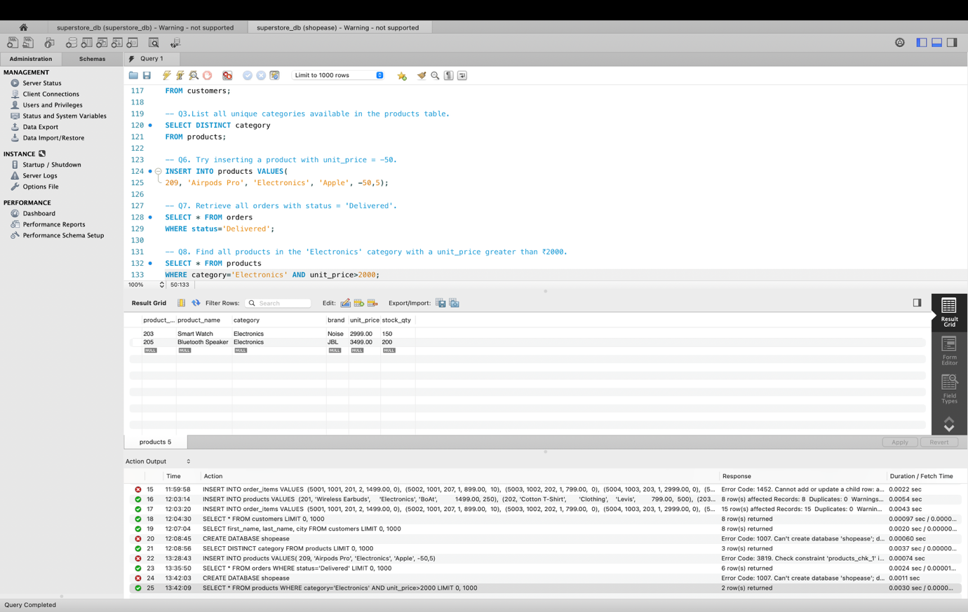

Q9. List all customers who joined in the year 2024 and belong to the state 'Maharashtra'.

- Again I have used and to club two conditions of join date and state from customers table.
- I have used like for checking join date condition such that it checks it the year is 2024 irrespective of month and year.

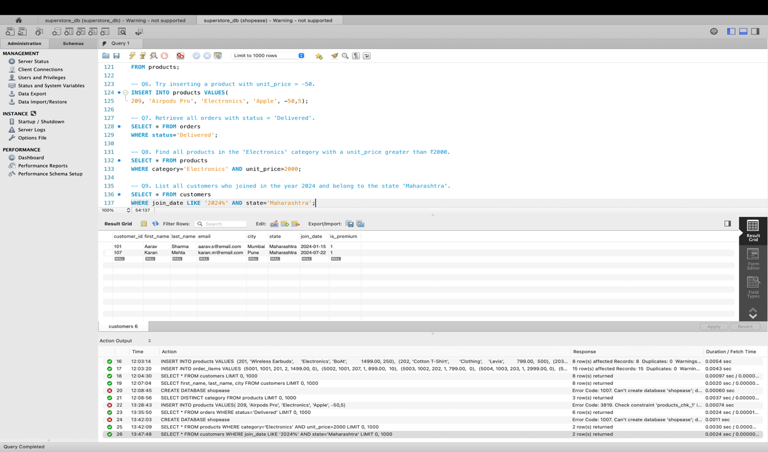
Q10. Find all orders placed between '2024-08-10' and '2024-08-25' (inclusive) that are NOT cancelled.

- I have used two conditions here to check from the orders table.
- For date checking I used between as it checks with both ranges inclusive.

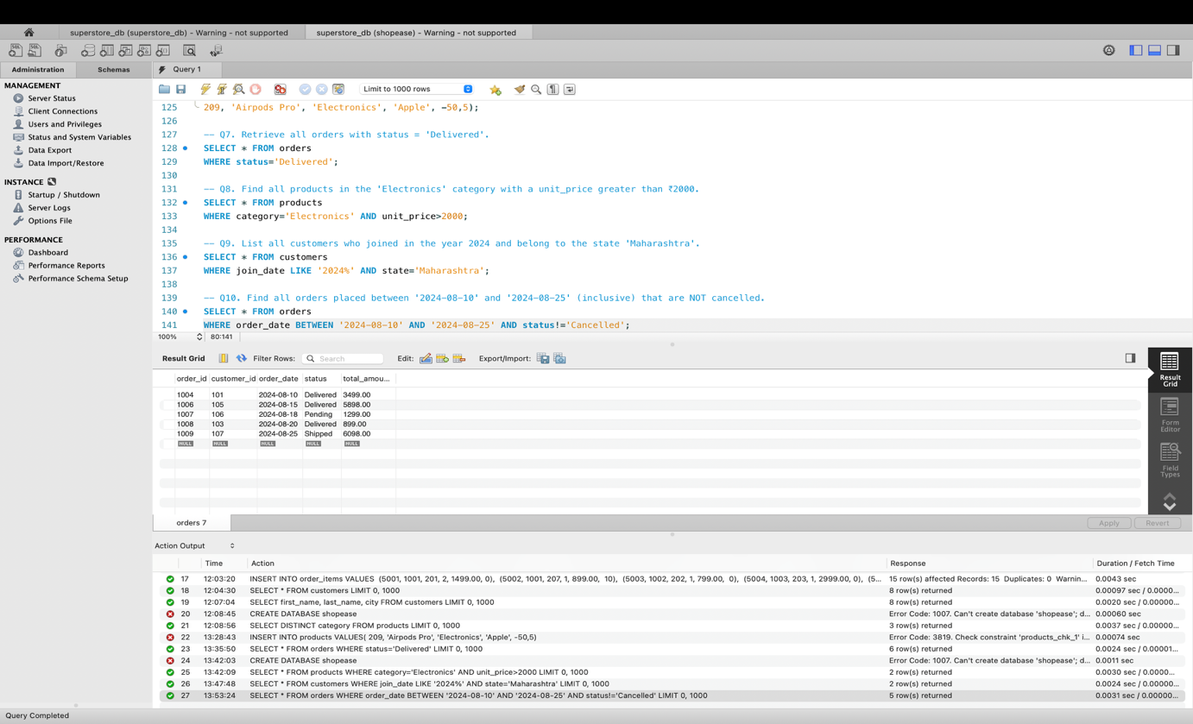

Q11. Explain what the index idx_orders_date does. How would it improve the performance of a query that filters orders by order_date? Write a sample query that would benefit from this index.

- The idx_orders_date index simply creates a sorted structure for order_date in orders table.
- The performance improves because of index as it does not filter order_date row by row instead it jumps directly to matching dates.
- I have given a query such that the order_date in a range is obtained.

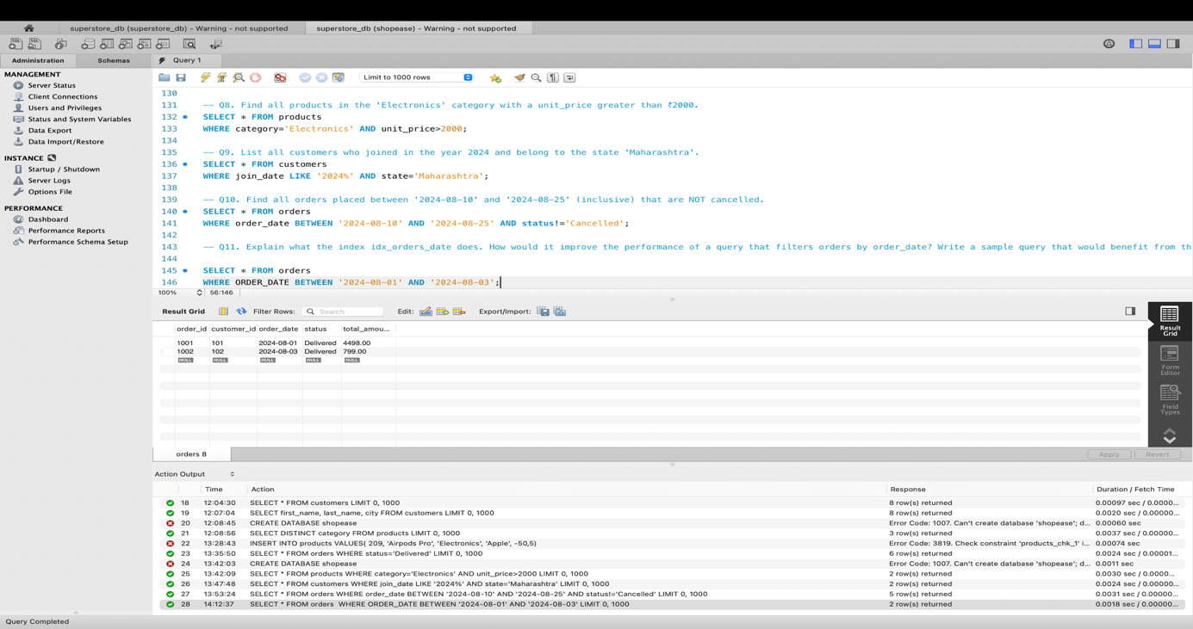
Q12. If you run: SELECT * FROM customers WHERE YEAR(join_date) = 2024; — would the index on join_date be used? Explain why or why not, and rewrite the query to be index-friendly (SARGable).

- No, the index on join_date is not used efficiently as YEAR() is applied to indexed column because instead of looking directly at indexed values the database transforms into year which makes the original index less useful.
- SELECT * FROM orders
WHERE ORDER_DATE BETWEEN '2024-08-01' AND '2024-08-03';

Section C — Aggregation (GROUP BY, SUM, COUNT, AVG, MIN, MAX)

Q13. Count the total number of orders in the orders table.

- I have used the count() to count the number of rows in the orders table so that it return number of orders.
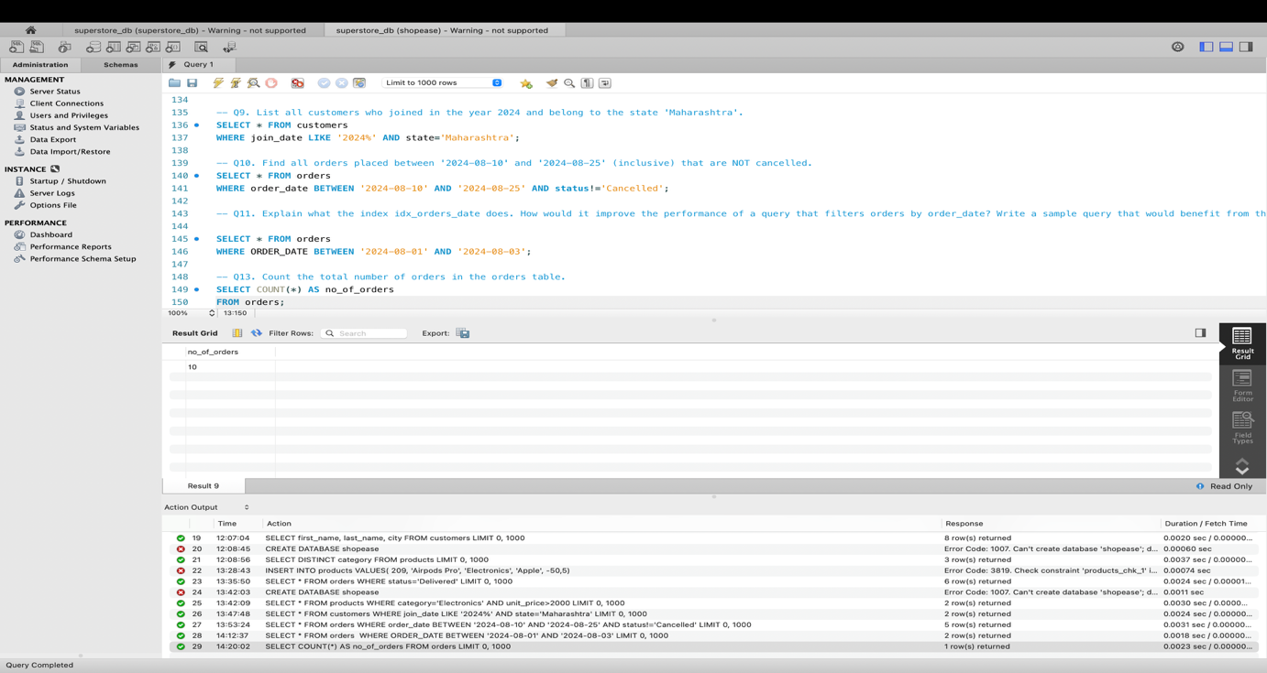

Q14. Find the total revenue (SUM of total_amount) from all 'Delivered' orders.

- I have used the sum() for adding the total amount of all delivered products.
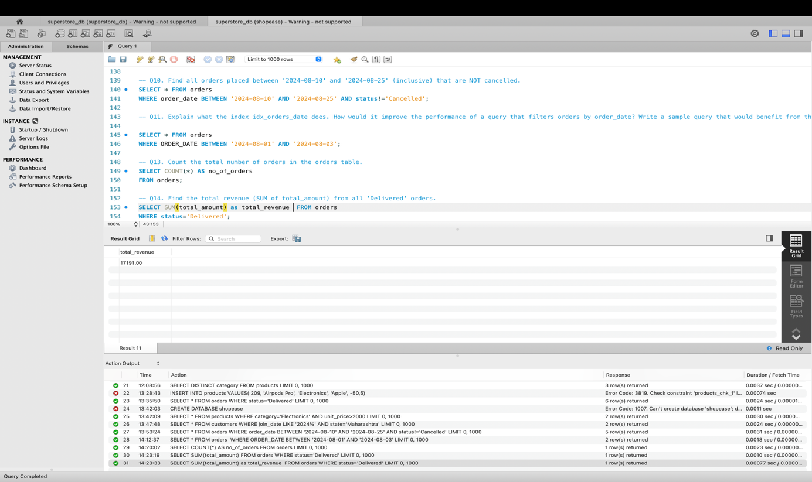
Q15. Calculate the average unit_price of products in each category.

- I have used avg() to calculate average price of products in each category and used GROUP BY to group the categories.
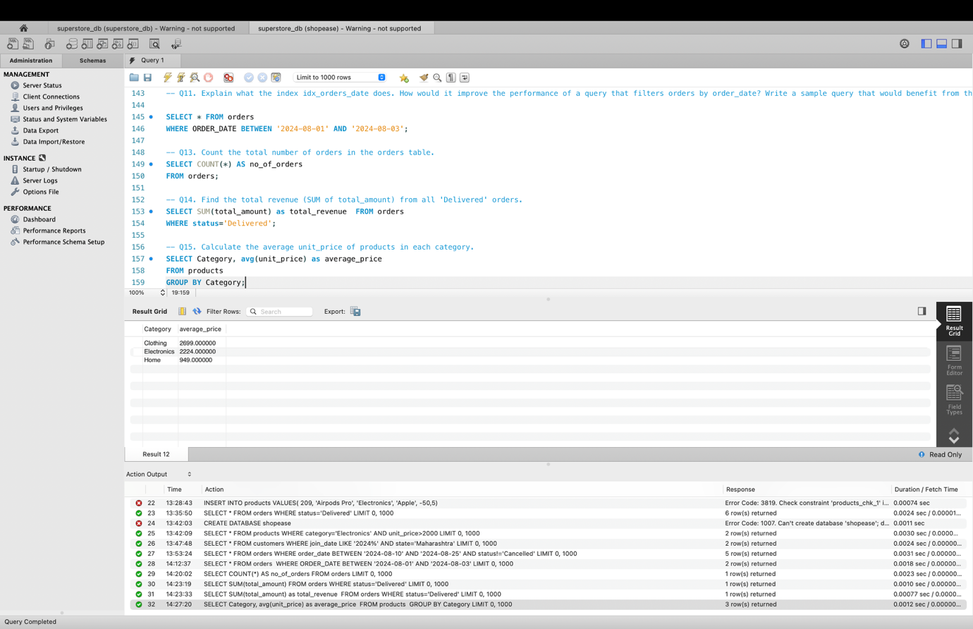

Q16. For each order status, find the count of orders and the total revenue. Sort the result by total revenue in descending order.

- I have used sum() for counting the orders and sum() for the calculating the total revenue.
- As each order status is specified I used GROUP BY for it and ORDER BY to give total revenue in descending order.
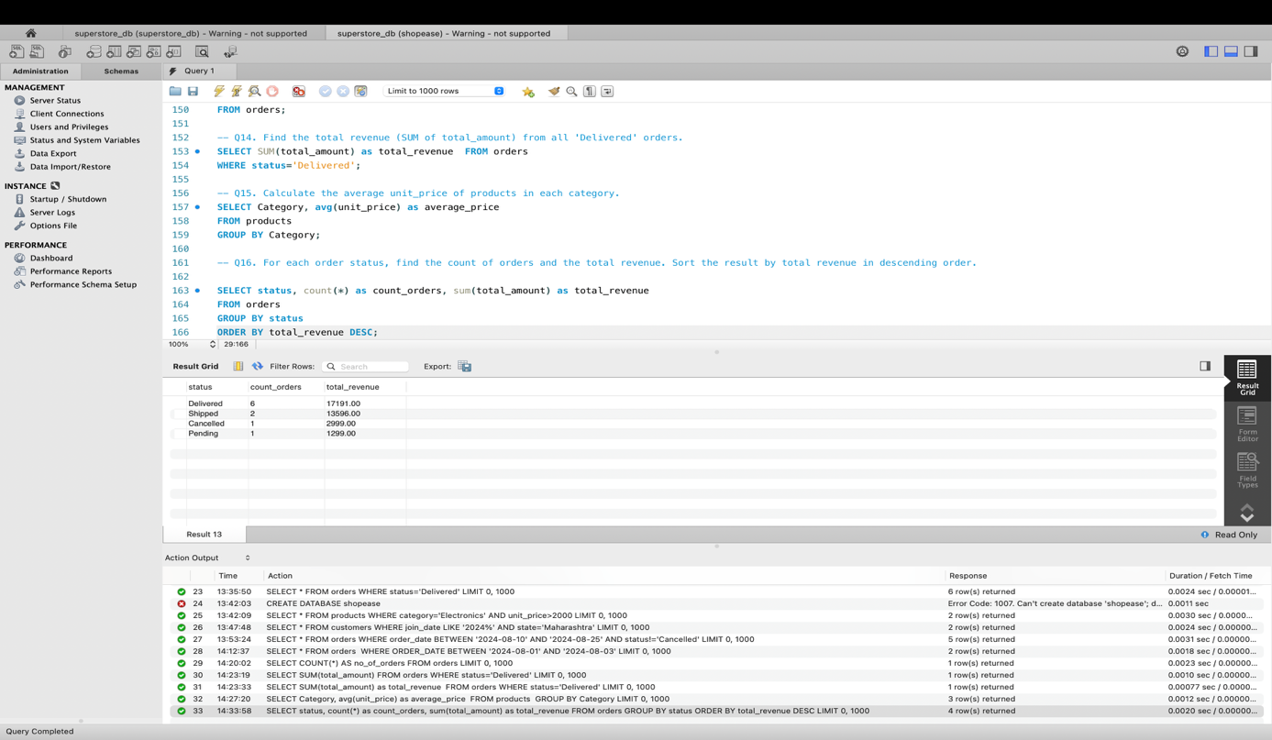
Q17. Find the most expensive (MAX) and cheapest (MIN) product in each category.

- I used max() and min() aggregate functions and group by to category from the products table.
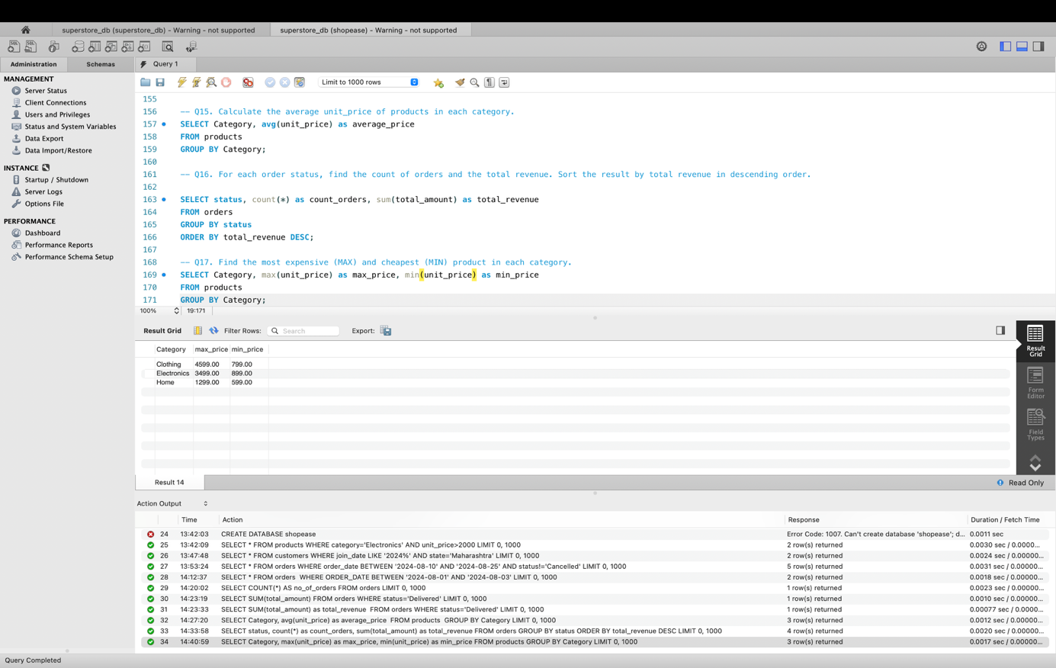

Q18. List all product categories where the average unit_price is greater than ₹2000. (Hint: Use HAVING clause)

- I have used avg() to find average of unit price and then found the average that is greater than 2000 using HAVING clause.
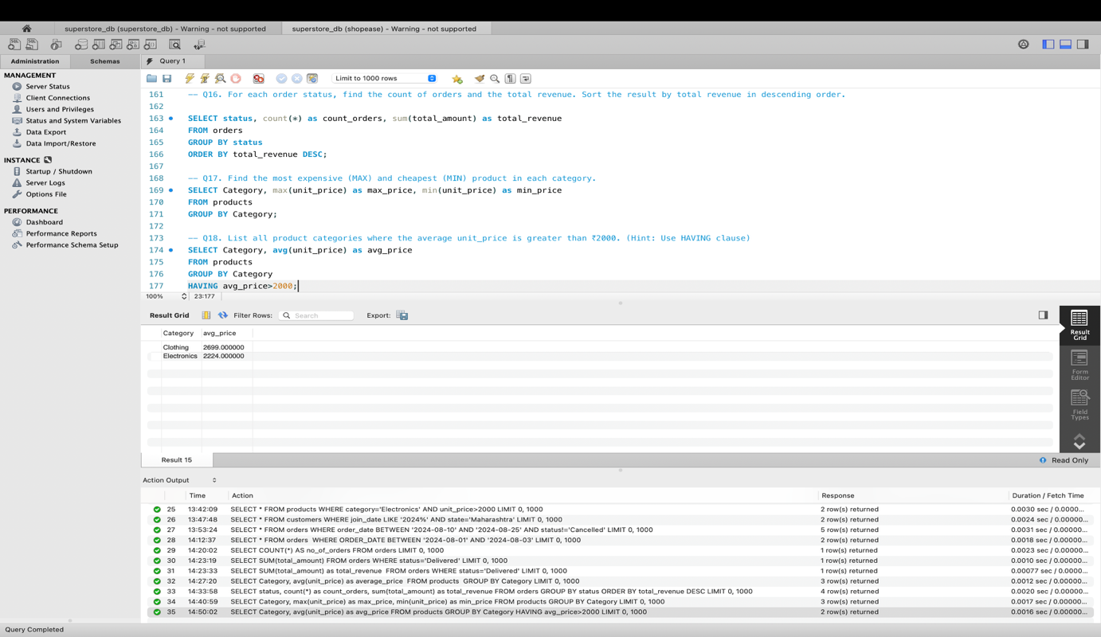

Section D — Joins & Relationships
Q19. Write an INNER JOIN query to display each order along with the customer's first_name and last_name. Show: order_id, order_date, first_name, last_name, total_amount.

- I have used Inner join to join orders and customer tables based on customer id.
- I gave the naming for orders as o and customers as c for ease of writing in this query.
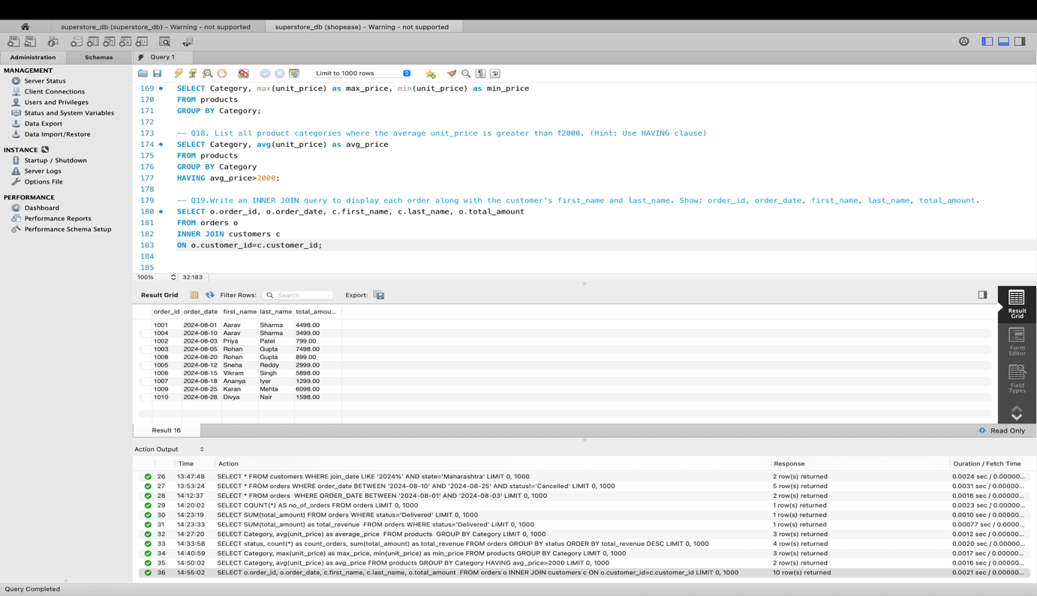

Q20. Using a LEFT JOIN, list ALL customers and their orders (if any). Customers with no orders should still appear with NULL values for order columns.

- I have performed left join on customer and order table based on customer id.
- As the above problem for ease of writing I used o for orders and c for customers.
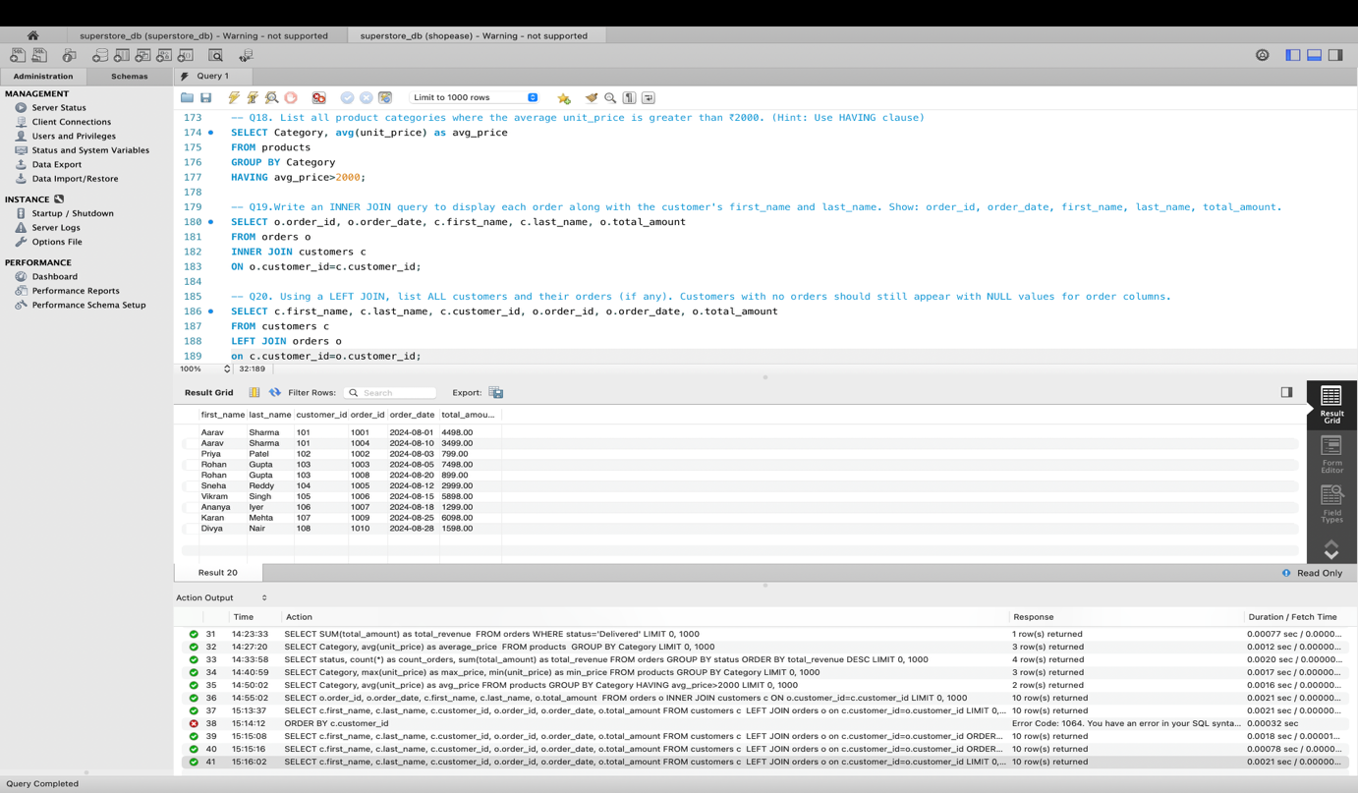

Q21. Write a query using JOINs across three tables (orders → order_items → products) to show: order_id, product_name, quantity, unit_price, and discount_pct for each order item.

- I have used JOIN to join order table and order_items table based on order_id.
- Then again JOIN to join products table based on product_id.
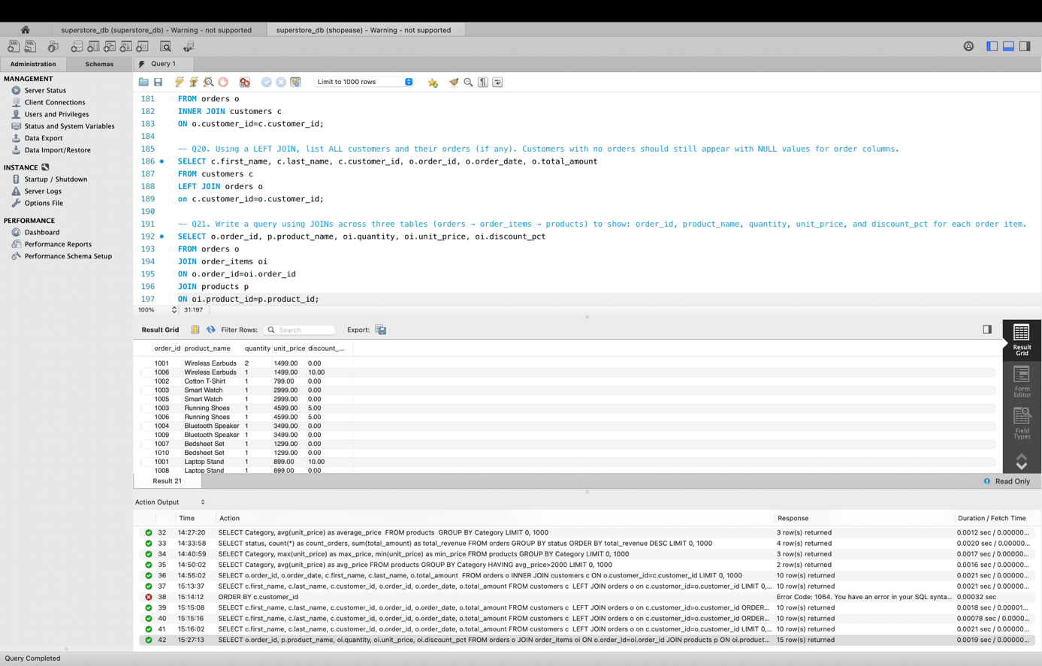
Q22. Explain the difference between LEFT JOIN and RIGHT JOIN with an example from this schema. When would you use a FULL OUTER JOIN?

- Left join returns all the rows from left table and the matching rows from right table.
- An example is as follows
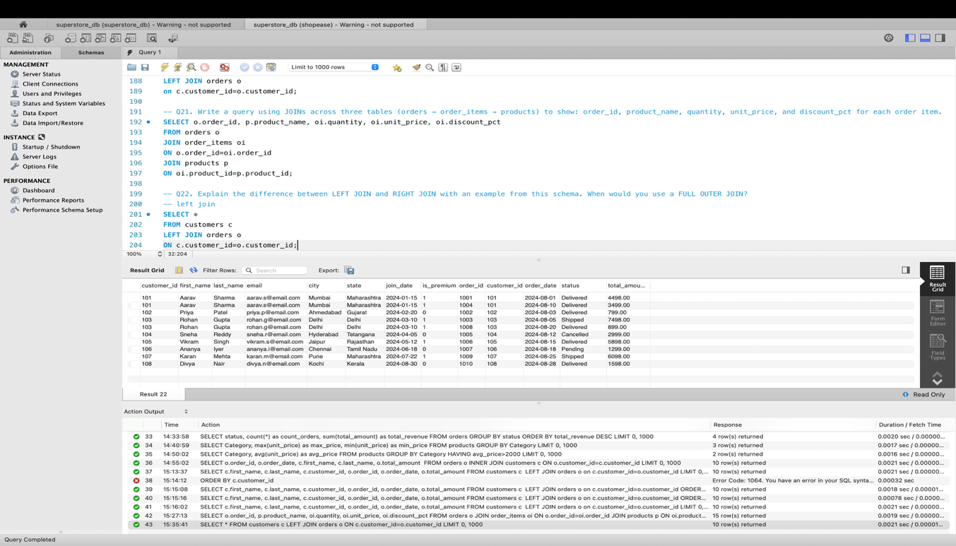

- Right join returns all rows from right table and matching rows from left table.
- Am example is shown as follows
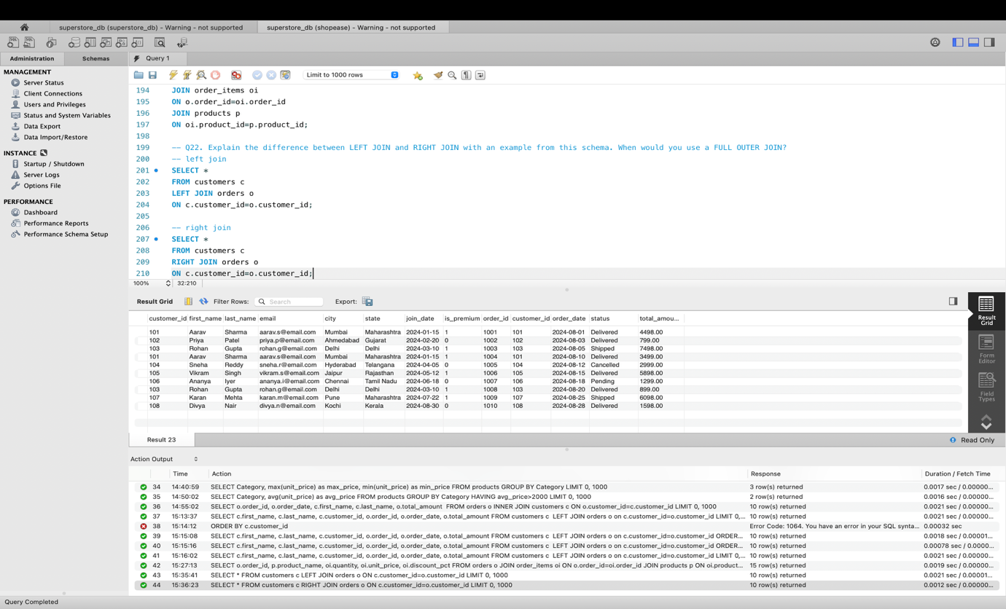

- Full Outer join return all rows from left table, all rows from right table and matching rows.

Q23. Identify all Foreign Key relationships in the schema. Explain what would happen if you tried to insert an order with customer_id = 999 (which doesn't exist in customers).

- The Foreign Key in order table is customer_id.
- The Foreign Keys in order_items table are order_id and product_id.
- If we try to insert an order with customer_id=999 it returns an error as it does not exist in the customers tablw.
- Foreign Keys ensure referential integrity.

Section E — Advanced Concepts (CASE, ACID, Transactions)
Q24. Write a query using CASE to classify products into price tiers:
• 'Budget' → unit_price < 1000
• 'Mid-Range' → unit_price BETWEEN 1000 AND 3000
• 'Premium' → unit_price > 3000
Display: product_name, unit_price, price_tier.

- I have used case and placed the conditions such that products are classified into three tiers.
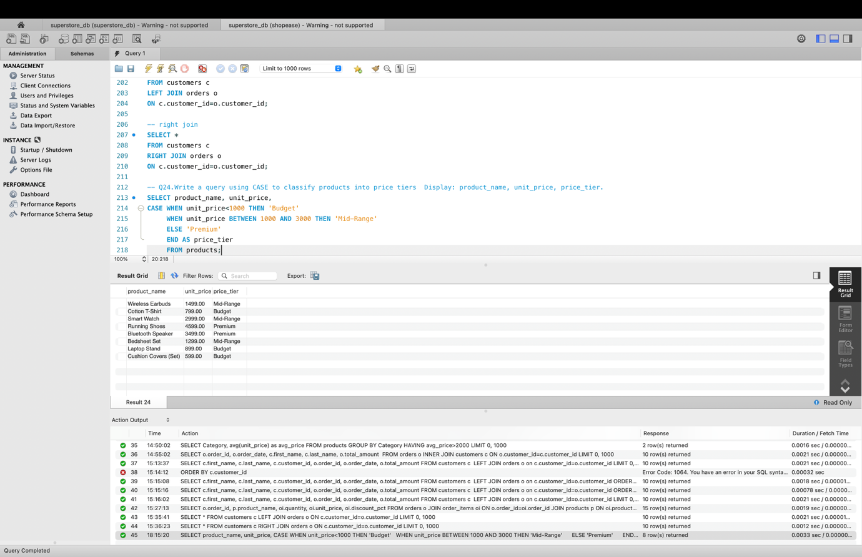

Q25. Using a CASE statement inside an aggregate function, count how many orders are 'Delivered' vs 'Not Delivered' (all other statuses). Display the result in a single row.

- I have used CASE and sum() as CASE converts each row either to 0 or 1 and sum() adds those values to get the count.

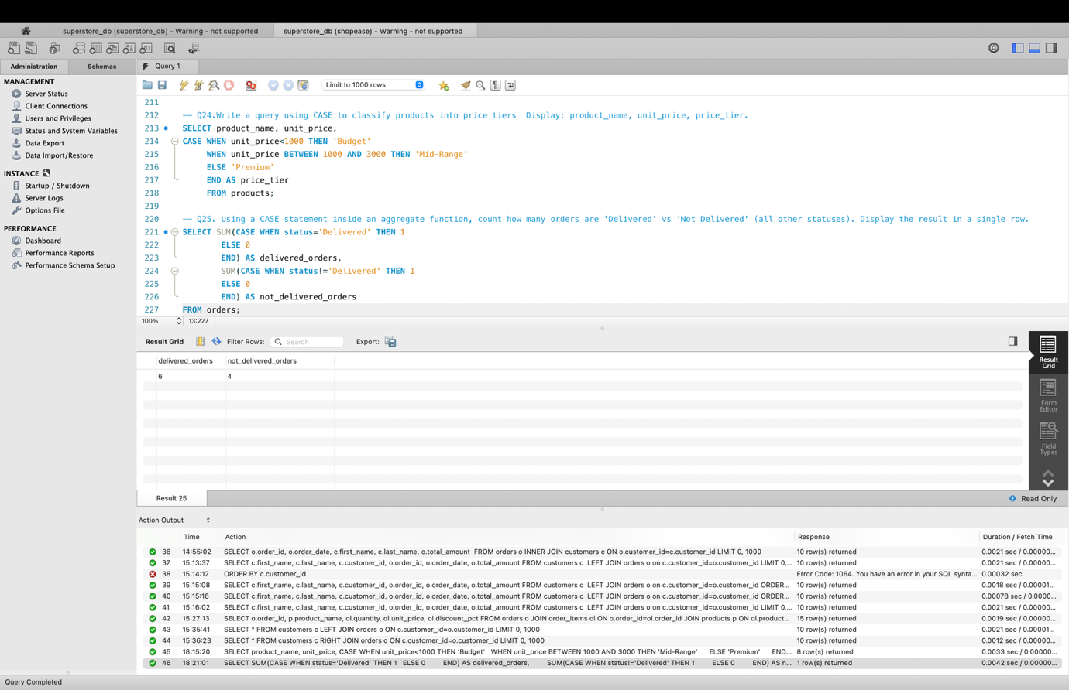

Q26. Explain each letter of ACID:
• A – Atomicity
• C – Consistency
• I – Isolation
• D – Durability
Give a real-world example (e.g., bank transfer) showing why each property is important.

ACID is a set of properties that ensures database transactions to maintain data integrity.
- A – Atomicity
This means either all operations succeed or no operation succeeds.
Example: If we are making a flight reservation then the operations generally include
- Booking a seat
- Making payment
- Update available seats
Even if the available seats is not updated then the entire transaction should be rollbacked.

- C – Consistency
A transaction must move the database from one valid state to another valid state ensuring all rules.
Example: Person A contains 600 and Person B contains 200 so the total is 800.
After transferring 100 from A to B, A will be left with 500 balance and B will get 300 but the total 800 still remains the same.

- I – Isolation
Multiple transactions should not interfere with each other at the same time.
Example: Person A and Person B both see 15A seat and booked it. But with isolation Person A gets the seat booked and Person B gets the message seat not available.

- D – Durability
Once the transaction is completed the changes are permanently stored.
Example: When payment is done in an e-commerce website the order gets confirmed and the order will be confirmed and the data is saved permanently.

Q27. Write a SQL transaction that does the following atomically:
1. Insert a new order (order_id=1011, customer_id=102, today's date, 'Pending', 1598.00)
2. Insert two order items for that order
3. Update the stock_qty of the purchased products
4. If any step fails, ROLLBACK the entire transaction. Otherwise, COMMIT.
Write the complete BEGIN...COMMIT/ROLLBACK block.

START TRANSACTION;
INSERT INTO orders
(order_id, customer_id, order_date, status, total_amount)
VALUES
(1011, 102, CURDATE(), 'Pending', 1598.00);

INSERT INTO order_items
(item_id, order_id, product_id, quantity, unit_price, discount_pct)
VALUES
(5016, 1011, 206, 1, 1299.00, 0);

INSERT INTO order_items
(item_id, order_id, product_id, quantity, unit_price, discount_pct)
VALUES
(5017, 1011, 208, 1, 599.00, 0);

UPDATE products
SET stock_qty = stock_qty - 1
WHERE product_id = 206;

UPDATE products
SET stock_qty = stock_qty - 1
WHERE product_id = 208;

COMMIT;

